**Thermal Analysis**

1. **MOSFET1**

For MOSFET IPP60R099P7, the RDS value for maximum desired temperature of $\left(T_{j}=100℃\right)$ can be found from datasheet:

: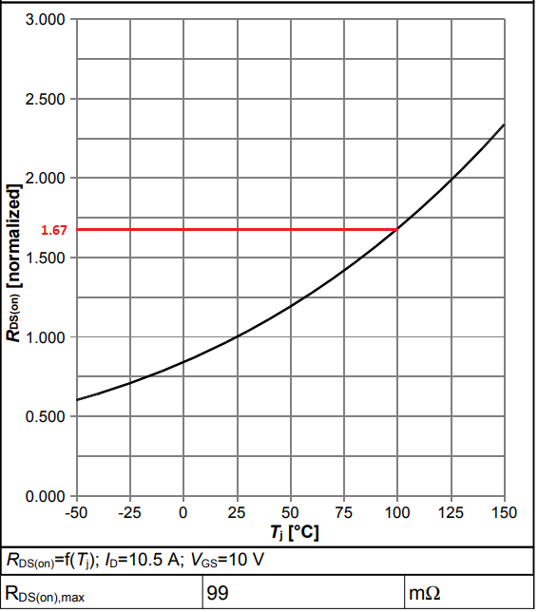

$$R_{DS}\left(T_{j}=100℃\right)=1.67*99mΩ=165mΩ$$

Thermal resistance, junction – case:

$$R_{thJC}=1.07℃/W$$

Thermal resistance, junction – ambient (leaded):

$$R_{thJA}=62℃/W$$

Typical thermal resistance of case – heat sink (flat, greased surface, approximately):

$$R_{thCH}=0.5℃/W$$

The sum of rise and fall times is:

$$t_{rise}+t_{fall}=15ns+5ns=20ns$$

In our application, switching frequency of the MOSFET is:

$$f_{sw}=75kHz$$

We should also find the rms output current and mean input voltage of the MOSFET. For this reason, simulation results are added:

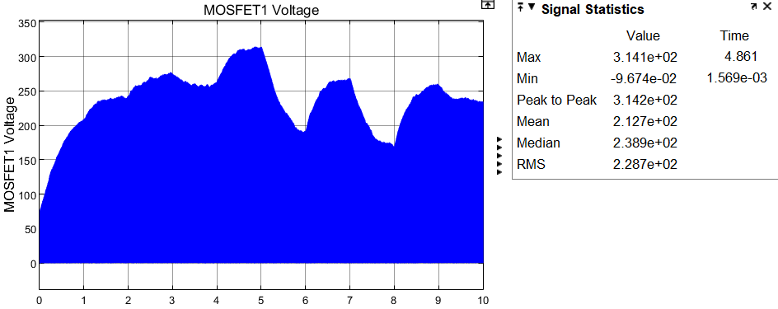

The mean value of the MOSFET input voltage is:

$$\overline{V_{in}}=212.7V$$

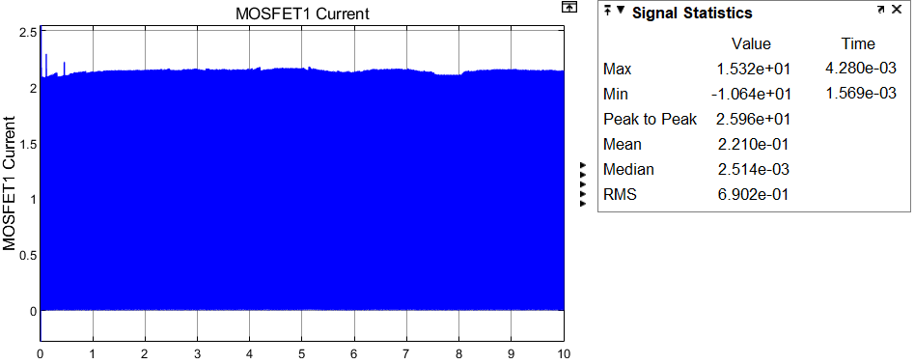

The rms value of the MOSFET current is:

$$I_{FET}\left(rms\right)=0.69A$$

The peak current in steady state (initial peak is omitted):

$$I_{OUT}=2.14A$$

The total power loss of MOSFET should be calculated:

$$P_{cond}=R_{DS}{I_{FET}\left(rms\right)}^{2}=(0.165*{0.69}^{2})W=0.079W$$

$$P_{sw}=\overline{V_{in}}I_{out}f_{sw}\left(t_{rise}+t_{fall}\right)=\left(212.7*2.14*75000*20*{10}^{-9}\right)W=0.683W$$

$$P_{loss}=P_{cond}+P_{sw}=0.762W$$

For normal conditions, let choose ambient temperature as $35℃$.

If no heatsink applied, the junction temperature is:

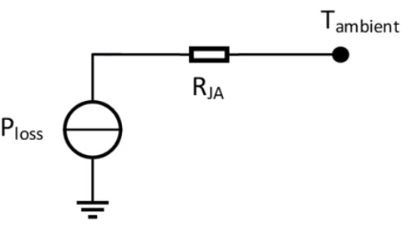

$$T_{junction}=T_{ambient}+P_{loss}R_{JA}=\left(35+0.762*62\right)℃=82.24℃$$

If there is a heatsink, maximum sink – ambient thermal resistance for maximum desired junction temperature of $T_{junction}=100℃$ is:

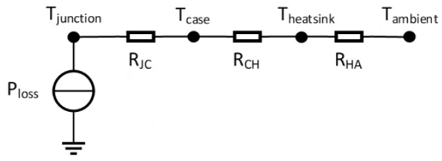

$$R_{HA}=\frac{T_{junction}-T_{ambient}}{P_{loss}}-R_{CH}-R_{JC}=(\frac{100-35}{0.762}-0.5-1.07)℃/W=83.7 ℃/W$$

1. **MOSFET2 (Replacement with diode)**

We should find the rms output current and mean input voltage of the second MOSFET. For this reason, simulation results are added:

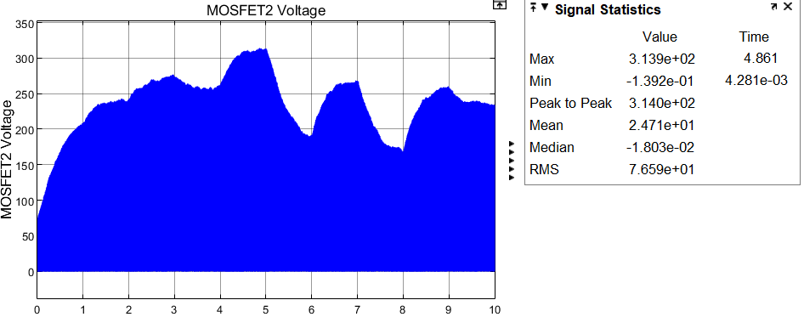

The mean value of the MOSFET input voltage is:

$$\overline{V_{in}}=24.7V$$

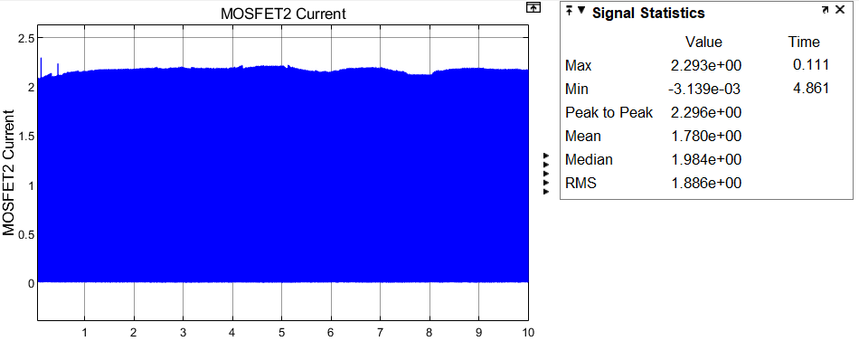

The rms value of the MOSFET current is:

$$I_{FET}\left(rms\right)=1.89A$$

The peak current in steady state:

$$I_{OUT}=2.16A$$

The total power loss of MOSFET should be calculated:

$$P_{cond}=R_{DS}{I_{FET}\left(rms\right)}^{2}=(0.165*{1.89}^{2})W=0.589W$$

$$P_{sw}=\overline{V_{in}}I_{out}f_{sw}\left(t_{rise}+t_{fall}\right)=\left(24.7*2.16*75000*20*{10}^{-9}\right)W=0.080W$$

$$P_{loss}=P_{cond}+P_{sw}=0.669W$$

For normal conditions, let choose ambient temperature as $35℃$.

If no heatsink applied, the junction temperature is:



$$T_{junction}=T_{ambient}+P_{loss}R_{JA}=\left(35+0.669*62\right)℃=76.48℃$$

If there is a heatsink, maximum sink – ambient thermal resistance for maximum desired junction temperature of $T_{junction}=100℃$ is:



$$R_{HA}=\frac{T_{junction}-T_{ambient}}{P_{loss}}-R_{CH}-R_{JC}=(\frac{100-35}{0.669}-0.5-1.07)℃/W=95.59 ℃/W$$

1. **Diode**

For Diode SD560B,

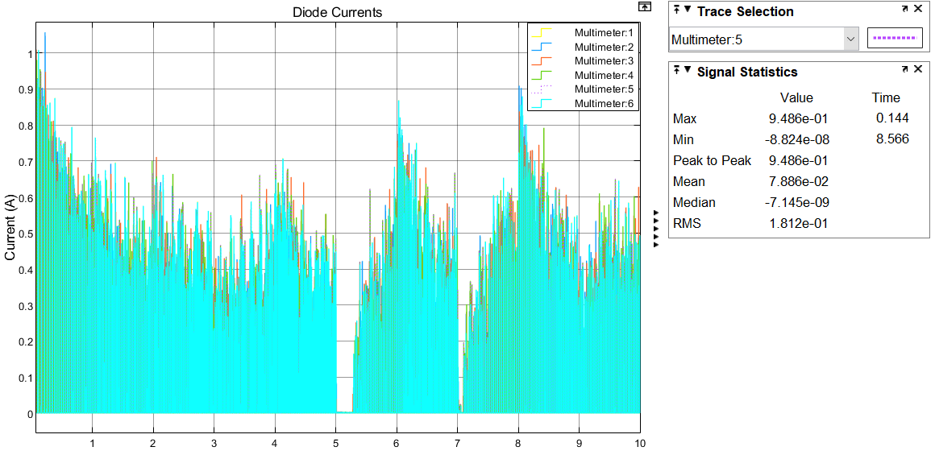

The mean value of the diode current, which has its maximum among 6 diodes in the bridge, is:

$$\overline{I_{D}}=78.9 mA$$

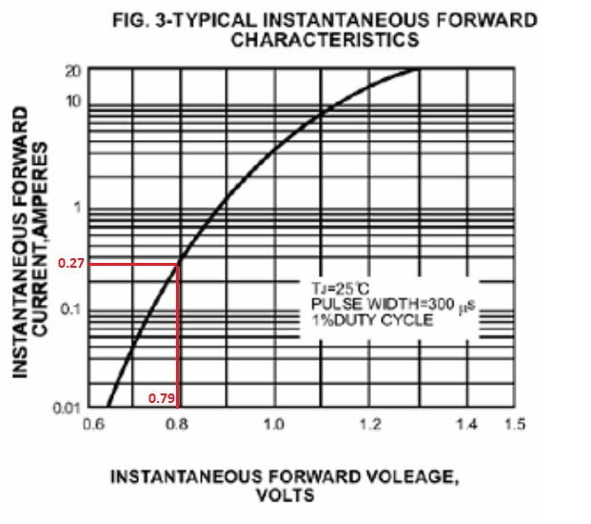

$$P_{loss}=V_{F}\overline{I_{D}}=0.79*0.0789=0.062W$$

For normal conditions, let choose ambient temperature as $35℃$.

Thermal resistance, junction – ambient (leaded) of this diode is:

$$R_{thJA}=20℃/W$$

If no heatsink applied, the junction temperature is:

$$T_{junction}=T_{ambient}+P_{loss}R_{JA}=\left(35+0.062*20\right)℃=36.25℃$$